# NNguyen - ESPGame

## Screenshots

### Running in IDE

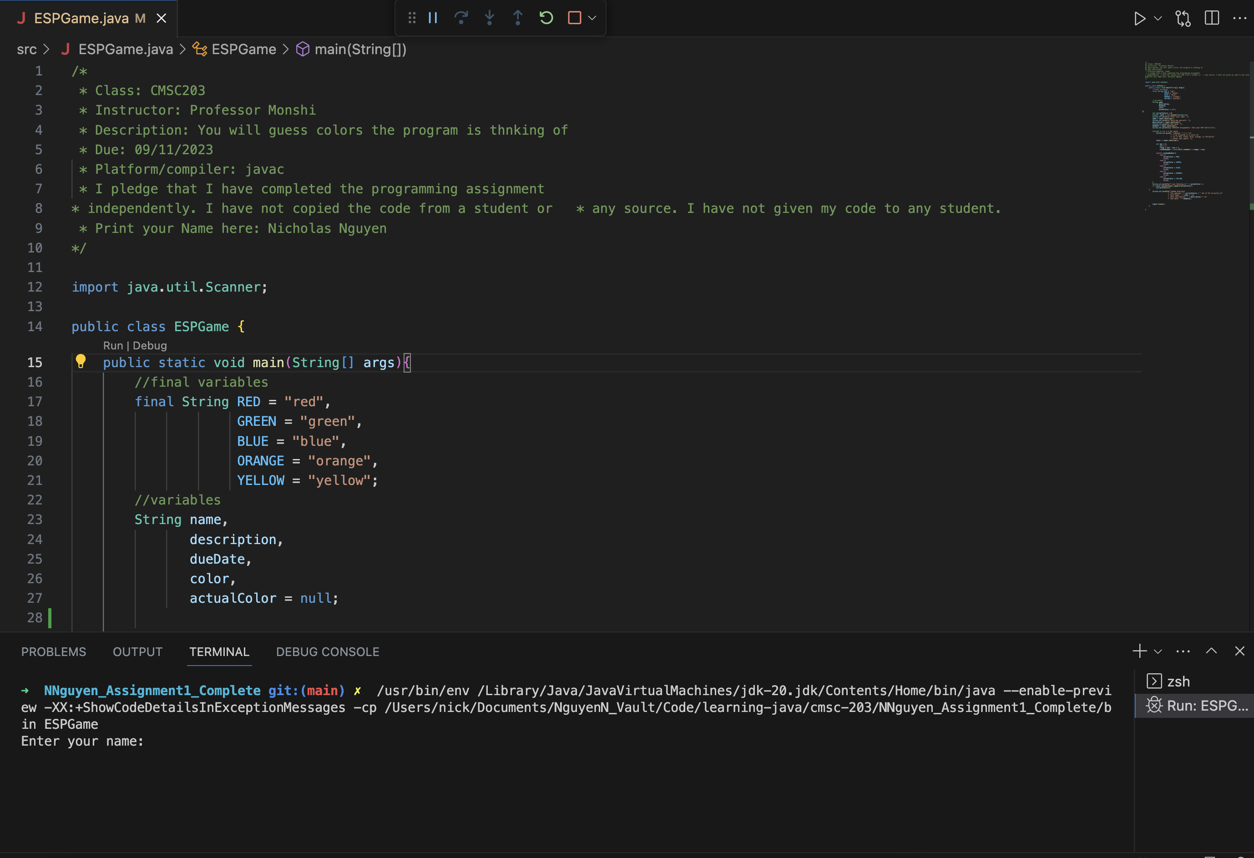

Important

This screenshot is on Visual Studio Code, my IDE of choice. During my AP Java course, I used Eclipse but it always threw me off. Please let me know if you would prefer I use it again. I was also unsure of what to screenshot in the IDE as the instructions were uncler to me.

### Running in terminal

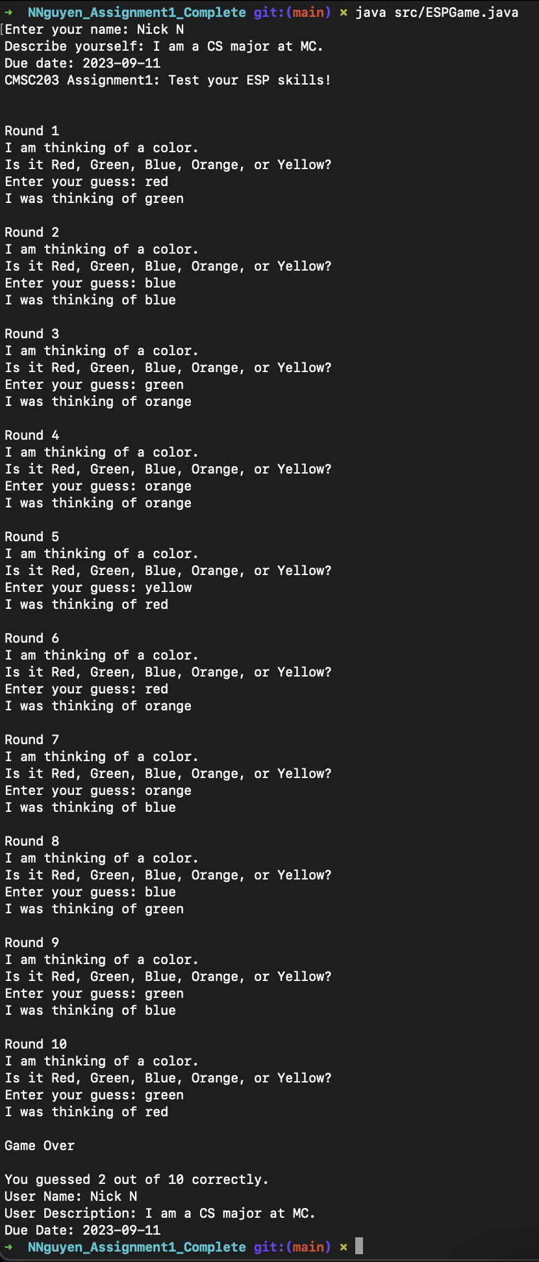

### ESPGame.java on GitHub

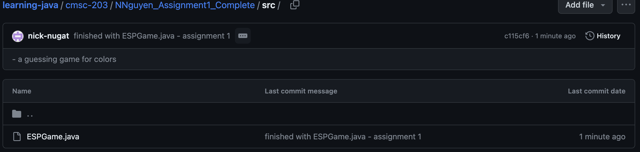

## Questions to answer



Write about your Learning Experience, highlighting your lessons learned and learning experience from working on this project.

I had a pretty good learning experience with this project and overall, it was enjoyable to code. I didn't learn much since I already have quite a bit of prior knowledge from my AP Java class.



What have you learned?

I learned that Java is pretty syntactically similar to C++. I didn't deal with things like switch statements much in AP Java.



What did you struggle with?

I didn't really struggle witih anything, but what did confuse me a bit was how, on **line 27**, I had to set actualColor = null since leaving it blank left me with some errors later on. This later on made sense to me, however, because without setting the variable to anything, nothing else dealing with said variable can do anything with just the variable declaration.



What would you do differently on your next project?

I wouldn't really do anything differently for my next project. I'm pretty pleased with how this one turned out.



What parts of this assignment were you successful with, and what parts (if any) were you not successful with?

I was successful with the entire assignment, thankfully.



Provide any additional resources/links/videos you used to while working on this assignment/project.

N/A